Carpooling API
Website Demo

Team
- Bassel Bakr Muhammed Sayyed - (24)
- Hossam El-Deen Faraj Doma - (25)

Project Supervisor: Dr. Ayman El-Shennawy

Computers and Systems department,
Faculty of Engineering,
Al-Azhar University, Cairo.



ABSTRACT

Carpooling refers to sharing a ride with other people in a car. By having more people share rides with each other, we can reduce the number of vehicles on the roads which in turn reduces traffic congestion and the need for more parking spaces. This reduction in number of vehicles, their fuel cost and the environmental problems they cause like air pollution and carbon emissions helps create safer environment for future generations.

ACKNOWLEDGMENTS

First of all, I thank Allah for benefits he gave us and I would like to express our gratitude to
Project Supervisor: Dr. Ayman El-Shennawy
Professor/Lecturer at the Computer and Systems Engineering department
For his guidance, encouragement throughout our work
We are greatly indebted to our faculty and the whole administration staff.

Team :
- Bassel Bakr Mohamed Sayed
- Hossam El-Deen Faraj Doma

Table of Content

ABSTRACT 1
ACKNOWLEDGMENTS 1
TABLE OF CONTENT 2

1. CHAPTER ONE: INTRODUCTION 6
1.1 Project Motivation 6
1.2 Project Aim and Objectives 6
1.3 Types of Carpooling 7
2. CHAPTER TWO: RELATED EXISTING SYSTEMS 8
2.1 Introduction 8
2.2 Existing Systems ……………………………………………………. 8
2.3 Overall Problems of Existing Systems 11
2.4 Overall Solution Approach 11
3. CHAPTER THREE: SYSTEM REQUIREMENTS ENGINEERING AND ANALYSIS 11
3.1 Introduction 11
3.2 Feasibility Study ……………………………………………………. 11
3.3 Targeted Users 12
3.4 Functional Requirements 12
3.5 Non-Functional Requirements 13

4. CHAPTER FOUR: SYSTEM DESIGN 14
4.1 Introduction 14
4.2 Context Diagram ……………………………………………… 16
4.3 Entity Relationship Diagram (ERD) 18
4.4 UML Use Case Diagram 19
4.5 UML Class Diagram 20
4.6 Graphical User Interface (GUI) Design 21

5. CHAPTER FIVE: SYSTEM IMPLEMENTATION 28
5.1 Introduction 28
5.2 Database Implementation 28
5.3 Graphical User Interface Implementation 35
5.4 Other Components Implementation 45
6. CHAPTER SIX: SYSTEM TESTING AND INSTALLATION 53
6.1 Introduction 53
6.2 Requirements Validation and Completeness 53
6.3 System Installation 53
7. CHAPTER SEVEN: PROJECT CONCLUSION & FUTURE WORK… 60
7.1 Future Work 60
7.2 CONCLUSION 61
8. CHAPTER EIGHT: APPENDEX 68

CHAPTER ONE: INTRODUCTION

1.1 Project Motivation
We noticed that many companies/institutions who want private carpooling system for their own specific needs build it from scratch, though there are many common bases in each implementation. We are offering a unified model API that can respond to these queries no matter what the institutions needs are.

1.2 Project Aim and Objectives
Building a unified carpooling API system that responds to different client needs both fast and reliable.

1.3 Types of carpooling

• Client first
The drivers drive their cars like a cab and receive a request from a client to pick him up and drop him at his destination.

• Driver first
The driver has a predefined plan and time for his trips. Clients can view his plan and, the number of available seats, possibly with whom they will travel. The client then can request the driver to pick him up and drop him somewhere along his trip path.

• Booking
Compared to the other 2 types listed above, this one is quite popular and often used when clients really need to arrive on time without delays.
The client either requests someone to pick him up from source to destination or views available drivers with work schedule matching his request.

CHAPTER TWO: RELATED EXISTING SYSTEMS

2.1 Introduction

There are plenty of online apps for carpooling, many of which consist of a server that connects drivers with passengers and client app, from which, the passengers can select one of the available rides for a relatively small cost compared to taking a cab.

2.2 Existing Systems
- Uber
- Careem
- Raye7
- Lyft

2.3 Overall Problems of Existing Systems

- Each company has its own system, possibly built from scratch.
- Distrust between drivers and passengers.
- Inconsistency of service due to network fluctuation.
- They work in very similar ways, making the competition between them mostly focused the cost and number of available drivers.
- They are actively acquiring their rivals

2.4 Comparison

The following table provides a comparison between the 2 most popular carpooling services in Egypt as of 2019:

 | Uber | Careem
Popularity | 483 cities worldwide. | 24 cities in the Middle East & Africa.
Registration | E-mail address + Mobile Number | E-mail, Mobile number or Facebook
Ride options | Economy & business cars, Bus | Economy, business cars, scooter, white taxi, water taxi, Bus
Rides availability | Improved availability with normal prices | Improved availability with normal prices
Request pickup time | Request it now or later with same charge for later rides | NOW or LATER, with extra charge for later rides
Pickup | Saves multiple addresses | Saves multiple addresses
Car request | Provides nearest rides & ETA | Provides nearest rides & ETA
Fare rate | Starting Fare: EGP 7, EGP 2.30 per km + EGP 1.6 per waiting minute, Minimum Fare = EGP 10 | Starting Fare: EGP 7, EGP 2.30 per km + EGP 1.6 per waiting minute, Minimum Fare = EGP 10
Airport surcharge | EGP 25 | EGP 20
Trip cancellation | Deducts EGP 10 after 2 minutes of ride cancelation | Deducts EGP 12 after 2 minutes of ride cancelation
Payment methods | Credit card or cash | Credit card, top up, cash or packages
Packages | No | Yes
Trip bill | Trip receipt is sent to client’s email with more details on the trip | Trip receipt is sent to client’s email with more details
Track your ride | Tracks your ride even when the app is closed | Provides tracking service but requires a lot of effort to retrieve after closing the app
Customer service | In app help service, with email communication | 24/7 call center plus in app help service, with email communication
Driver evaluation | Rating through the app | Rating through the app and SMS
Sharing ride Info | Shareable | Shareable
Splitting ride fare | Possible | Not possible
Trip history | Complete history of your trips, payments and driver details on the mobile app and website | Complete history of your trips, payments and driver details on the mobile app and website

2.5 OVERALL Solution Approach

- Provide one universal API system that gets the job done.
- Make it usable by any institution/company to their liking.
- More reliable/trusted system because it is open to developers/contributors.

2.6 Proposed solutions

This project tries to address possible solutions for some of the aforementioned problems:

- Creating a carpooling service that can be used by any company or individual for an affordable price and reasonable plans.
- With the separation of the service from the usual flow, companies can focus more on hiring trusted drivers for their business or delegate recruitment process to professional agencies. While at the same time, the work on improving carpooling efficiency will be the focus of the server maintainers and reflected for all users.
- With carpooling service being shared with multiple companies, it becomes much easier to collect useful data about most frequent places passengers often visit and make charts and heat maps for drivers to give them an idea about which roads are more profitable and how frequent some rides are.
- Most frequent rides can be cached by the service and retrieved much faster in subsequent queries improving the overall performance and, in some cases, the roads can be stored locally on client’s device, reducing both server load and client’s need to ping the server frequently, especially when the network is poor.

CHAPTER THREE: SYSTEM REQUIREMENTS ENGINEERING AND ANALYSIS

3.1 Introduction

The software requirements engineering and analysis describe features and functionalities of the target system including these processes:
- Feasibility Study
- Requirement Gathering
- Software Requirement Specification
- Software Requirement Validation

3.2 Feasibility Study
Study if system with its requirement is applicable or not.

System needs:
- Server
- Interface Designer
- Authentication
- Encryption
- Database
- API calls

*All requirements are available

3.3 Targeted Users

Companies and Institutions looking for a private, fast, reliable carpooling system.

3.4 Functional Requirements

Requirements related to functional aspect of the software
- Registering
- Signing in
- Making API queries
- Receiving query responses

3.5 Non Functional Requirements
Requirements not related to functional aspect of software. They are implicit or expected characteristics of the software

- Logging
- Storage
- Performance
- Cost
- Flexibility
- Accessibility

4.0 CHAPTER FOUR: SYSTEM DESIGN

4.1 Introduction

It describes desired features and operations in detail, including screen layouts, business rules, process diagrams, pseudo code and other documentation. The most creative and challenges phase of the software development life cycle is software design. The term design describes final software and the process by which it is developed. The purpose of the design phase is to plan a solution of the problem specified by the requirements document. It also includes the construction of programs and program testing. Design takes us toward how to satisfy the needs. The design of a system is perhaps the most critical factor affecting the quality of the software; it has a major impact on the later phase, particularly testing and maintenance. The output of this phase is the design document

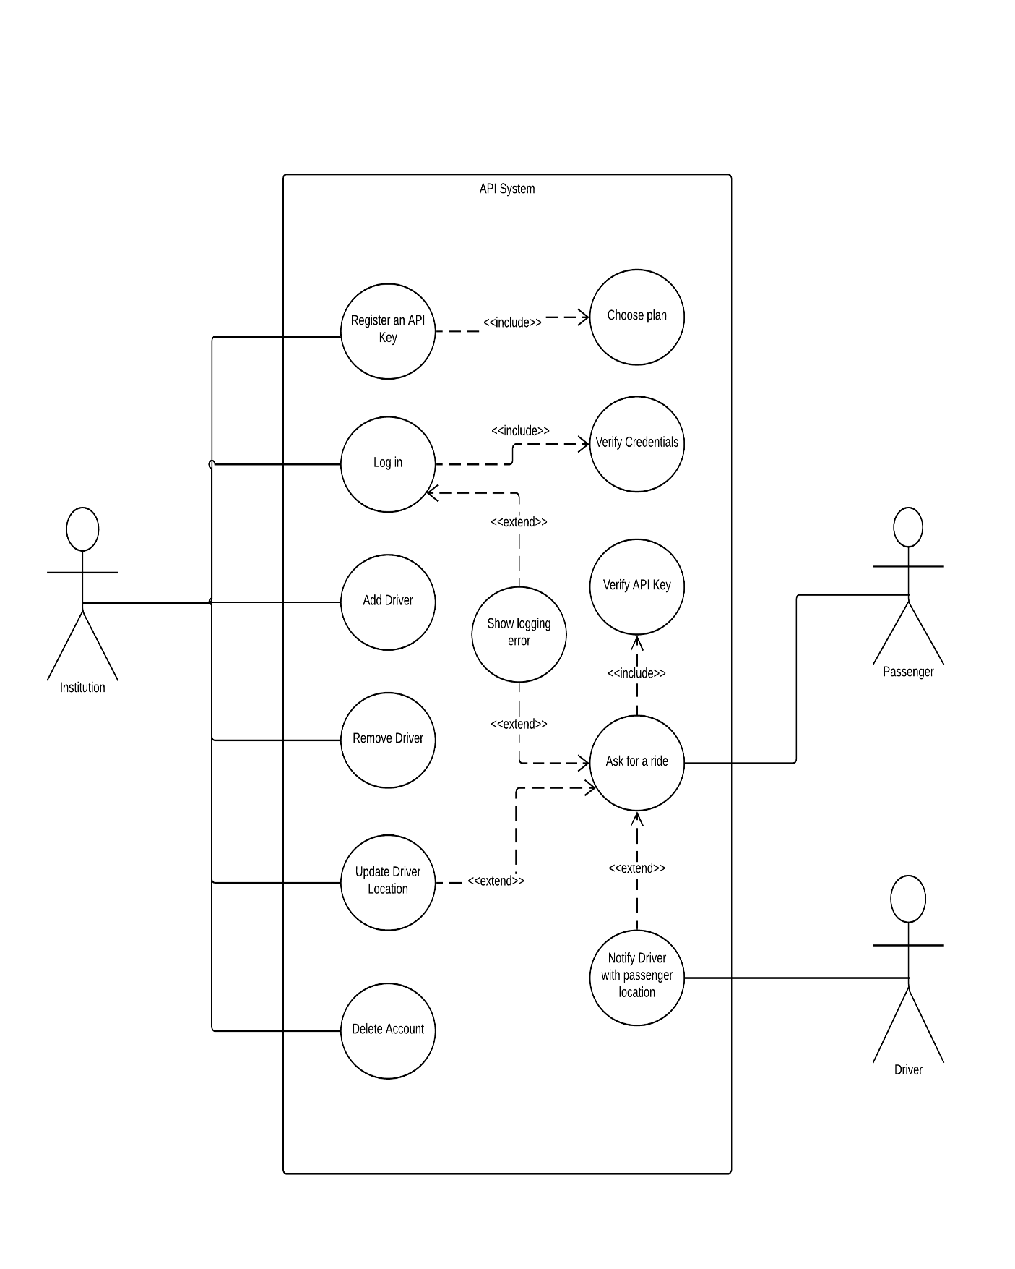
UML Use Case DiagraM

Graphical User Interface (GUI) Design

- Select to Sign up or login
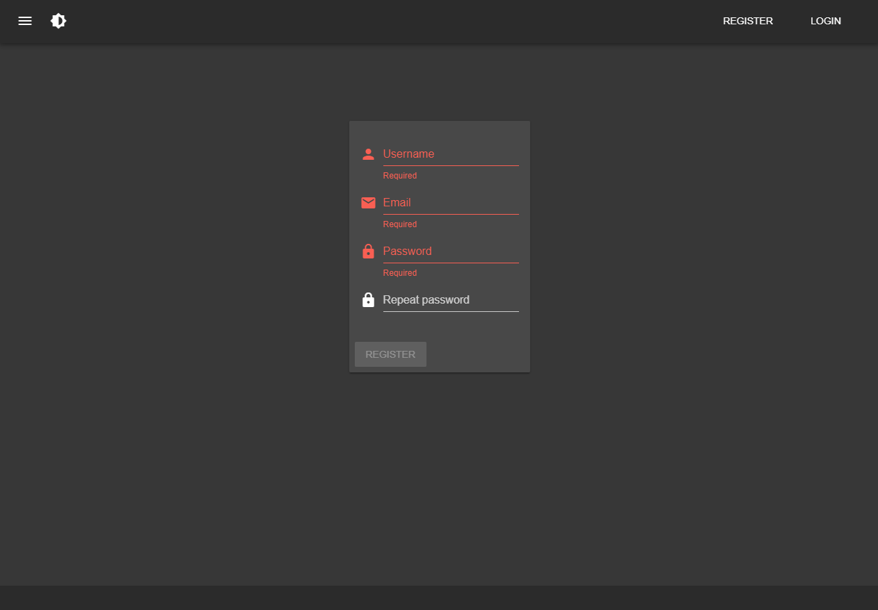

- Sign up

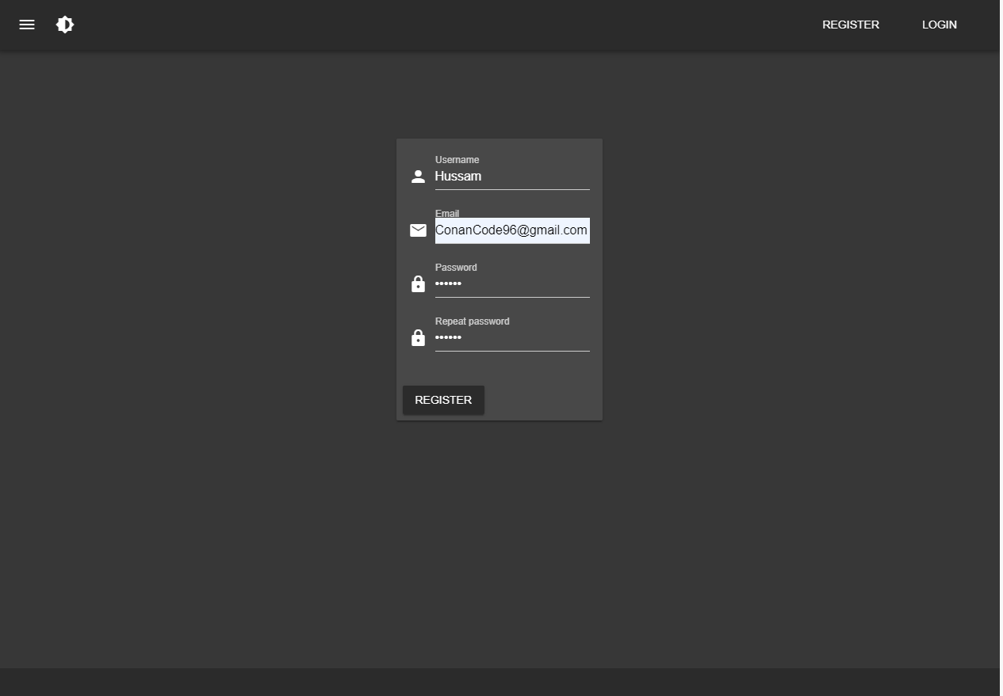

- Login
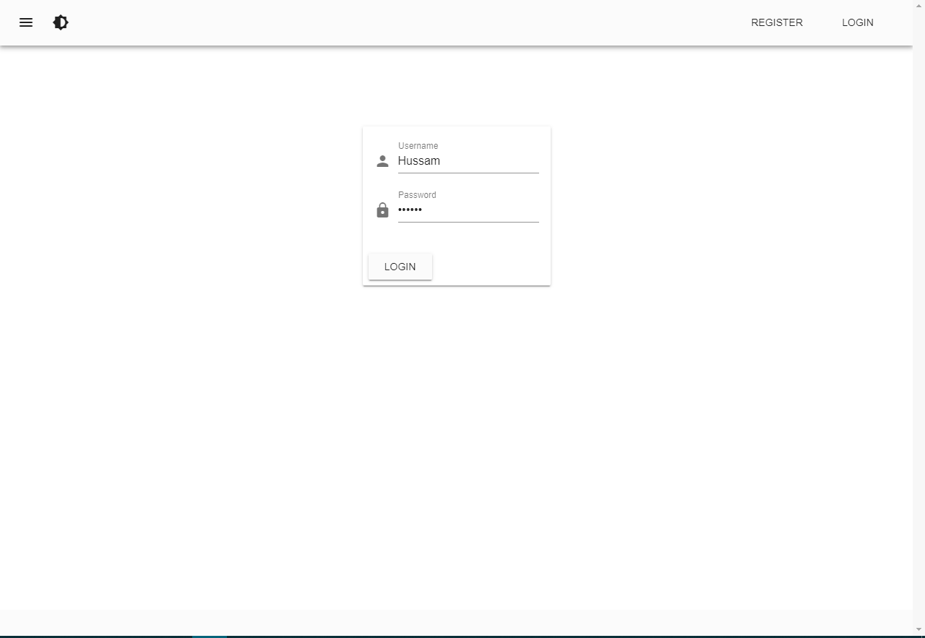

- Querying the API

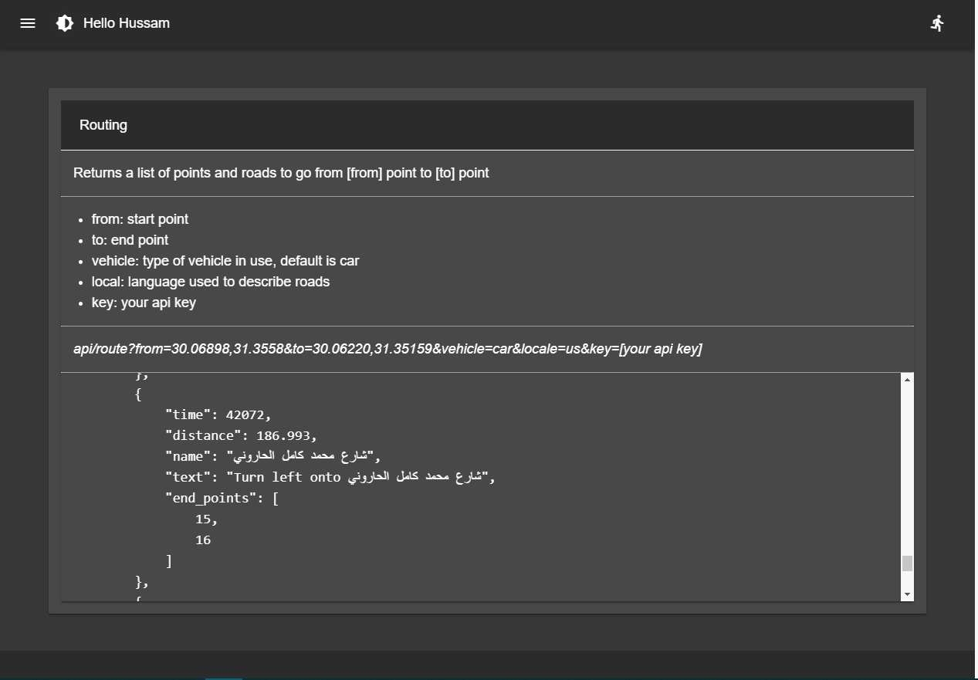

CHAPTER FIVE: SYSTEM IMPLEMENTATION

5.1 Introduction

Implementation of the system is divided into
- Database
- GUI
- API
- APP Development

5.2 Database Implementation

User Data Dictionary
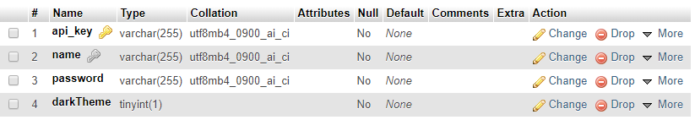

5.3 Implementation

The implementation can be broken into 3 main parts:

- Server Side:
Where the service resides and operates.

It has to support multiple concurrent requests without blocking users as much as possible. Node.JS fits in perfectly owing to its asynchronous nature and the simplicity of scaling the server in response to heavier work loads.

It’s also possible to delegate performance critical parts to C/C++ as Node.JS has bindings for both of them.

It’s also worth mentioning that using Node.JS unifies the languages used in both back-end and front-end (JavaScript) reducing the problems often encountered when someone works on different code bases written in different languages and makes the mistake of writing correct code yet not in the correct language.

The server will offer API end points, through which the client app can interact and exchange location data.

To support multiple companies/individuals, API access will be restricted to registered members using a token (or API Key). When a user registers and fills the forms and billing information, he will be given a unique token id that helps the API identifies him and the plans to choose from. Subscribing to any plan will allow him to use the API and send requests per the guide lines of each plan.

When the subscription ends, the user can choose to renew his plan.

The server only offers carpooling service; the API user is the one who customizes the service to his needs. For example: a user might choose to hire only female drivers and accept rides for female passengers and their young children. (like Pink Taxi)

- Client side:
The front-facing part interacting with the server behind the scenes using web APIs (AJAX).

There are many options to choose from, like Ionic, React & Vue Native and Flutter.

Flutter, React and, Vue Native provide better performance compared to Ionic, especially that React uses virtual DOM and avoids editing the real DOM unnecessarily. But Ionic beats them in terms of supported platforms as they only support mobile applications while Ionic is mature enough and supports Web + Mobile applications using one code base

The performance issues addressed above regarding Ionic aren’t much of a concern because most of the work is server side and the client only needs to display the data relied by the server in a convenient way.

- Registration website:
The website that users can use to register to our service and acquire a token for accessing the API end points

The design will be made with Vue.JS for its component based system, styled with Vuetify framewor, a responsive theme with rich library of ready-made components based on Material Design.

CHAPTER SIX: SYSTEM TESTING AND INSTALLATION

6.1 Introduction

Software testing against requirements and system specification.
Include:
  - Software validation
  - Software verification

Database tested on MongoDB

6.2 Requirements Validation and Completeness

completed Requirement:

1. Registering
2. logging in
3. Calling the API

Uncompleted Requirement:

  - Generating reports
  - Generating Heatmap

Test CASES

1. Registering:



Test Name | Username Not Null
Function Tested | Registering username
Sample Input | ‘null’ or empty string
Expected Output | Warning that the field is required to be non-empty


‘WHEN THE FIELD IS NON-EMPTY’



Test Name | Email Checking
Function Tested | Registering
Sample Input | ‘Your_mail@Mailbox.Com’
Expected Output | Ok! If Email Matches The Regex, Otherwise No.



‘Email conforms to the email regex’



Test Name | Password not null
Function Tested | Password field
Sample Input | Password not empty / null
Expected Output | Warning! Cannot proceed while the password is null

Test Name | Password Not less than 6 characters
Function Tested | Password Field
Sample Input | Length of password field >= 6 characters
Expected Output | Ok! If password length is >= 6 characters Otherwise a warning is displayed

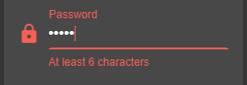

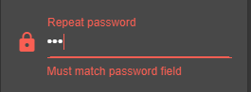

Test Name | Repeat Password Not different
Function Tested | Repeating the password should be exactly the same as the original password
Sample Input | Any password that matches the originally entered password while registering
Expected Output | Ok! If Passwords match, Otherwise a Warning is raised.

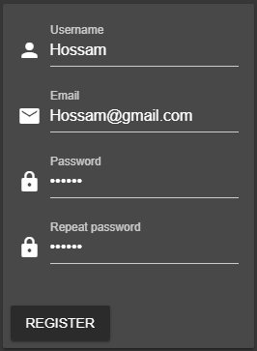
-Successful registratioN-

2 Loggin In

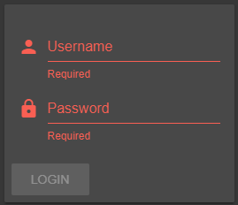

Test Name | Logging in
Function Tested | Logging in
Sample Input | Valid registered username and password pair
Expected Output | Ok! If both the username and password pair Match a record in the database, Otherwise a Warning is raised.

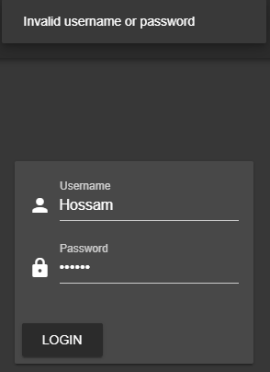
-Failed login attempT-

-successful login attempt-

6.4 Project Software and Hardware Requirements

Hardware Requirement:
- I5 Processor Based Computer
- 4GB-RAM
- 80 GB Hard Disk
- Monitor
- Internet Connection

Software Requirement:
- Any Windows 7 or higher / Unix / Linux OS
- VSCode
- Web Browser
- POST MAN

Front End: Vue.js
Back End: Node.js
Database: MongoDB (can be easily changed into an other database with minimal code changes)

6.5 Libraries used

Library | Stable version
Axios | 0.19.0
Bcrypt | 3.0.6
Body-parser | 1.19.0
Cookie-parser | 1.4.4
Express.js | 4.17.1
Graphhopper-js-api-client | 0.11.1
Mongoose | 5.6.1
MySQL | 2.17.1
Passport | 0.4.0
Passport-local | 1.0.0
Uuid | 3.3.2
Vue | 2.5.22
Nodejs | 10.16.0

Database >> MongoDB
Server >> NodeJS (localhost@3000)
Website >> VueJS (localhost@8080 for DevServer)

7.0 CHAPTER SEVEN: PROJECT CONCLUSION AND FUTURE WORK

7.1 Future Work:
- Generate reports about API traffic
- Adding extra functionality of heatmaps

7.2 CONCLUSION

App consist of TWO main stages:

- Frontend
Implemented in Vue.JS using 3 screens(home, register, login).
Website is responsive for different Screen sizes from small mobiles to large tables and in 2 language Arabic and English depend on mobile language.

- Backend
Implemented in Node.JS, handles authentication, encryption, decryption of credentials, calling Graph Hopper APIs, implementing the matching algorithm, fetching and putting data from and to the frontend GUI.

